Celebrating the Impact of LEADER on
Rural Communities

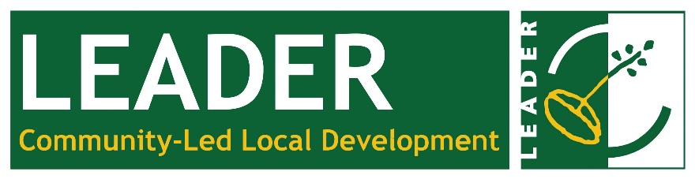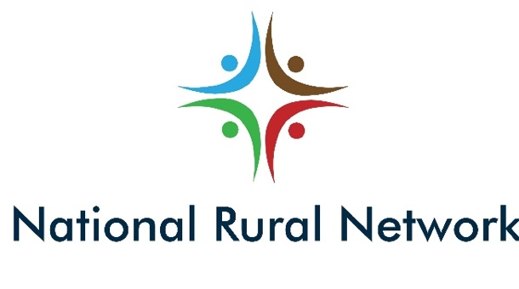

Below you will find a list of the questions you will need to complete to enter this campaign.

Entries open on Tuesday, 1 September at 9am here: https://www.nationalruralnetwork.ie/a-celebration-of-leader-campaign/

- Enter Your Basic Information
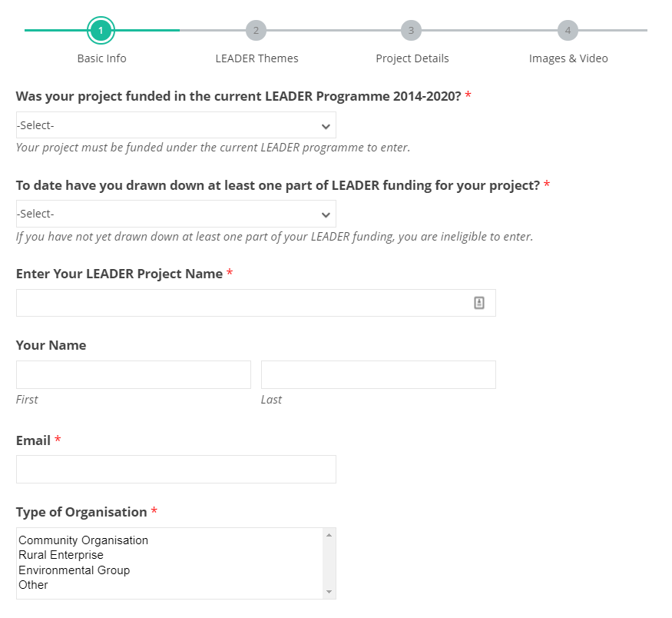

- Highlight Your LEADER Themes

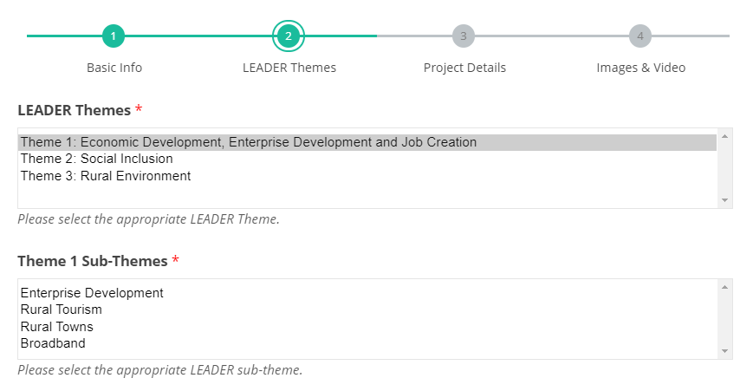

- Define Your LEADER Project
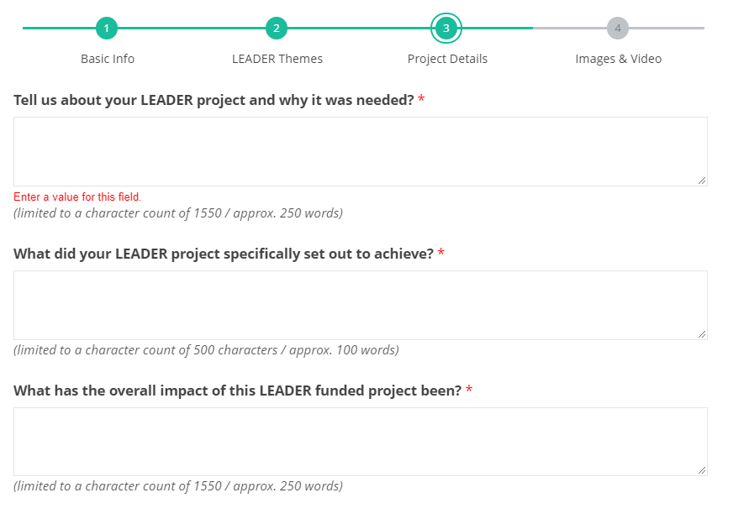

- Enter Your Media (3 Images and 1 Video) / Terms & Conditions

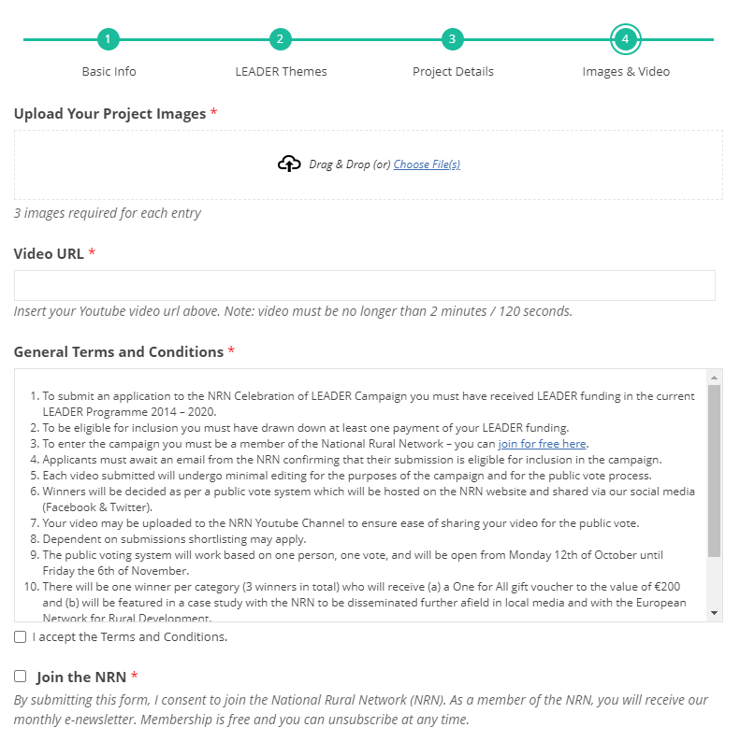
See you on Tuesday, 1st September!
Entries will open here: https://www.nationalruralnetwork.ie/a-celebration-of-leader-campaign/

